**SWE 585 - Fall ‘24**

**Introduction to Game Programming**

**Term Project**

**Efe Göçmen - 2022719225**

**Project Topic & Challenge**: Level of Detail (LOD) Management in Open-World Scenes

**Rationale**:

Open-world games feature vast environments with numerous objects, which can strain system resources if not managed properly. Inefficient LOD management can lead to excessive GPU and CPU usage, causing low frame rates and a poor gaming experience. Optimizing LOD is crucial for balancing visual quality with performance, especially on devices with limited resources.

[1]

**Experiment Design**

**Objective:**

Design a controlled, repeatable experiment to analyze how different LOD settings impact system performance in an open-world environment.

**Environment:**

Create a large terrain representing an open-world setting using Unity.

**Objects:**

Populate the scene with a significant number of objects such as trees, rocks, buildings, and other props.Make sure each object has multiple LOD models: High, Medium, Low, and Ultra-Low detail.

**Testing environment**  
  
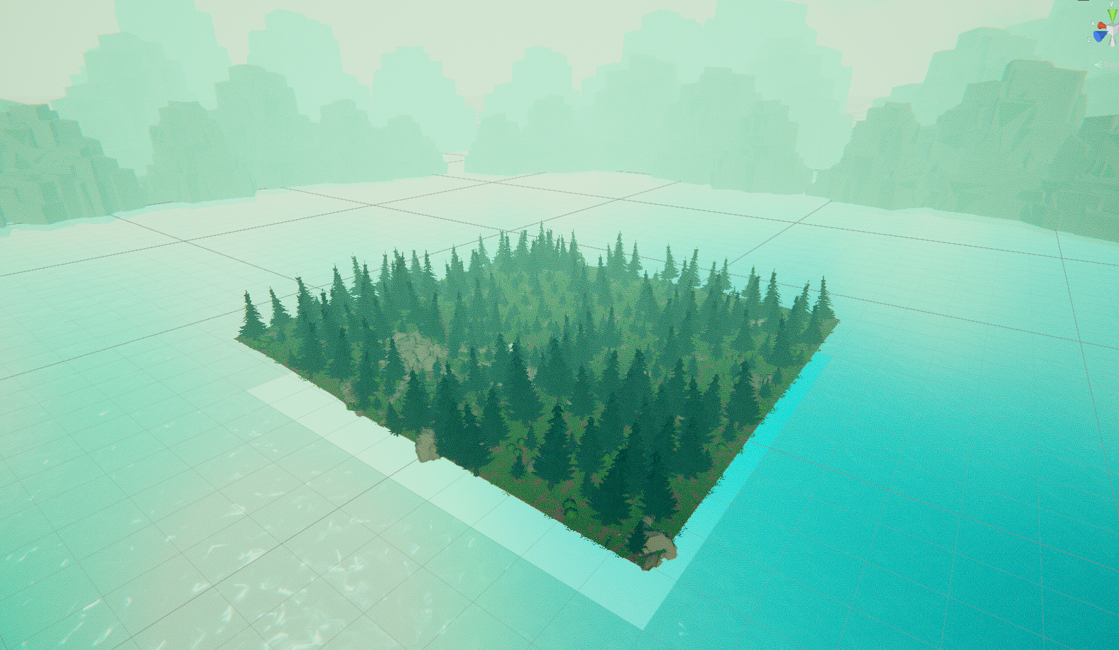

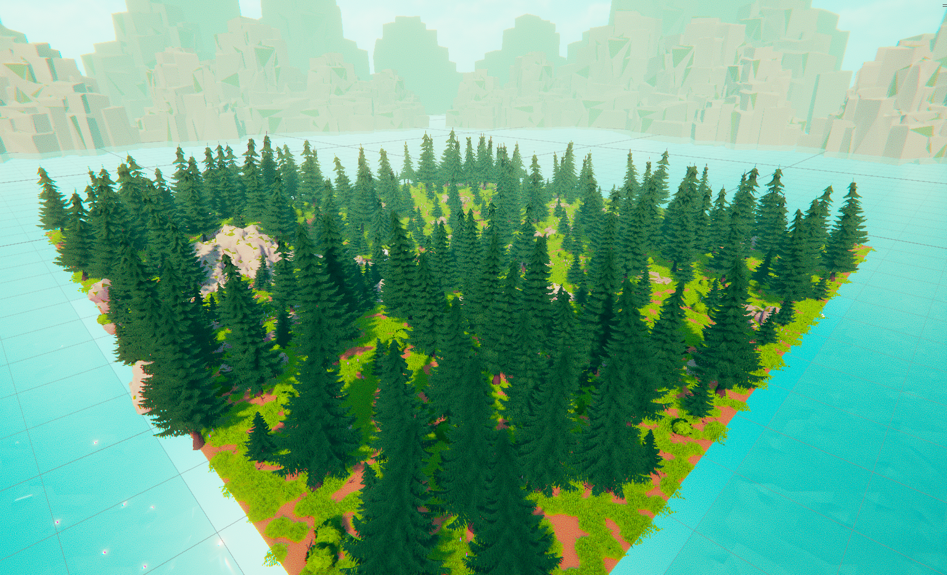

**Figure 1** *A testing environment populated with props such as trees, grasses and rocks.*

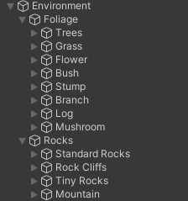

**Figure 2** *Primary props that has significantly populate the testing environment are grasses and trees, the testing will be based on their LOD parameters.*

The small number of secondary props such as stones, rocks make their performance impact almost negligible. On the other hand, spruce trees and grasses are aggressively used during scene design. Lastly spruce trees are the most detailed props among all others having up to 2058 triangles at LOD 0

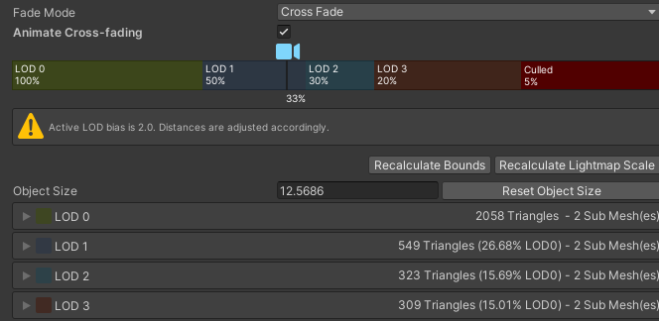

**Figure 3** *Spruce trees can reach 2058 to 2300 triangles depending on the variation.*

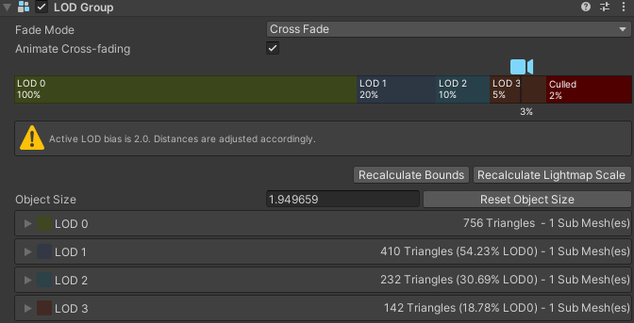

**Figure 3** *Rocks have almost one third of a standard spruce tree’s triangle count.*

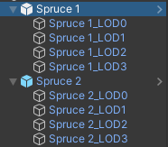

**Figure 4** *Spruce tree prop variations and their respective LOD levels.*

There are two variant of Spruce Tree prop, Spruce 1 and Spruce 2. They slightly differ in detail therefore the triangle counts per LOD level.

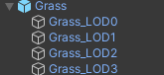

**Figure 5** *There is only one grass variant.*

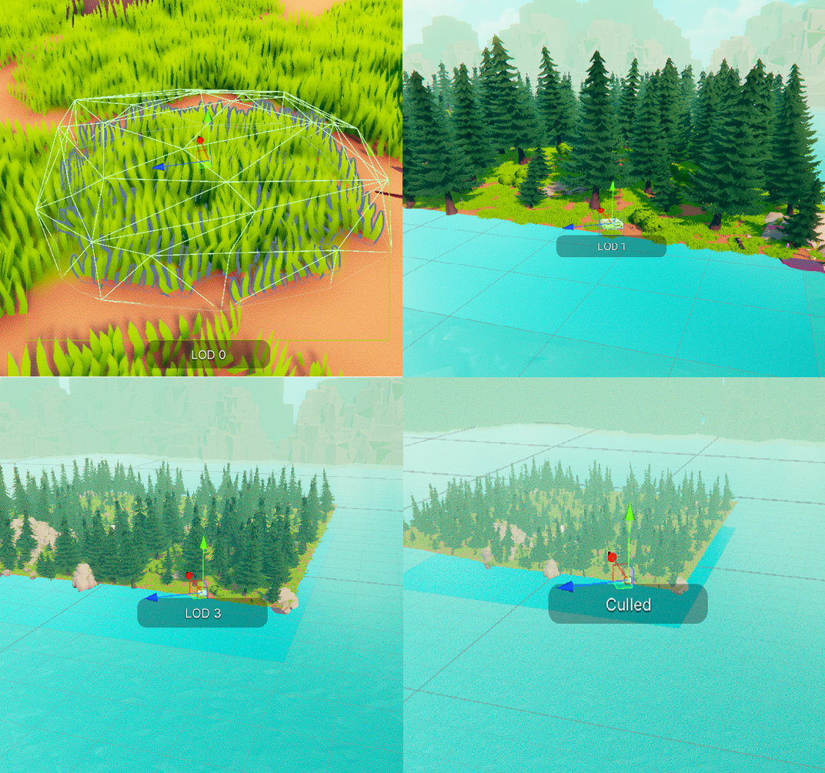

**Figure 6** *The distances, where LOD level increase for grass prop.*

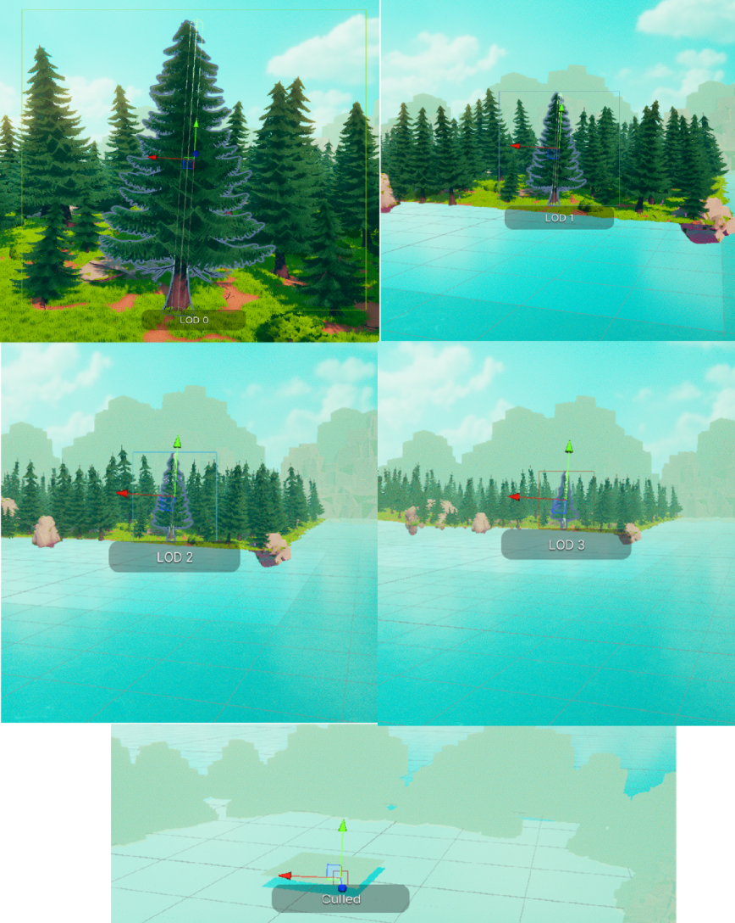

**Figure 7** *The distances, where LOD level increase for Spruce Tree 1 prop.*

It is possible to configure the distance-to-camera or % coverage levels to trigger LOD level switch. The effects of different LOD level setups can be seen at the figures 9 and 10.

Cross Fade mode enables smooth transition from different LOD levels with Cross Fade disabled different LOD levels instantly change from one model to another thus create a funky graphic behaviour.

After LOD 3 culling level starts, the objects don’t get rendered at all. It is reasonable if the character does not see the object or the object is too far away.

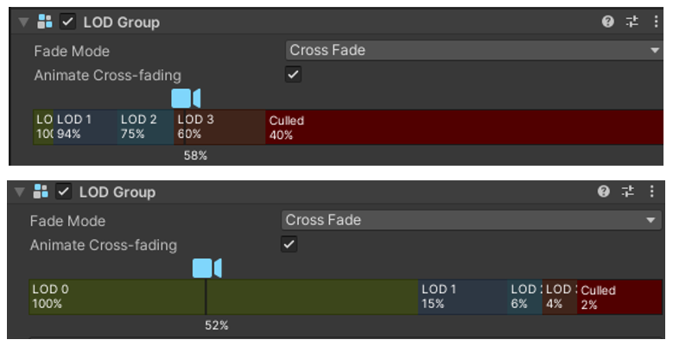

**Figure 8** *LOG Group class adjustments for LOD level detail demonstration.*

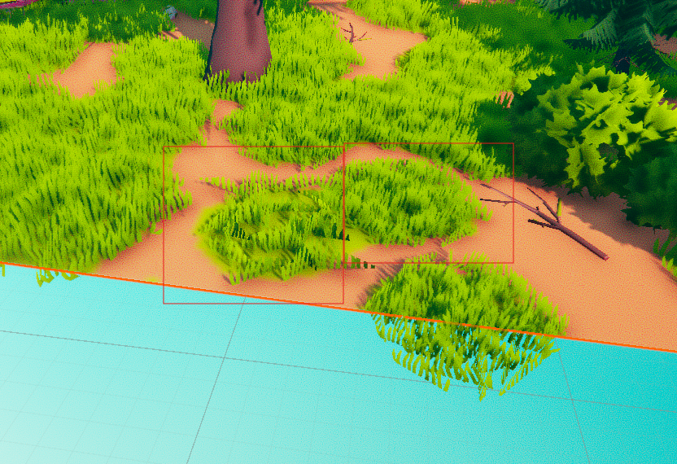

**Figure 9** *Grass prop at the left-hand side is currently rendered with LOD3 whereas the grass prop at the right-hand side is at the default level LOD0. It is quite obvious how complexity of the prop changes with different LOD levels.*

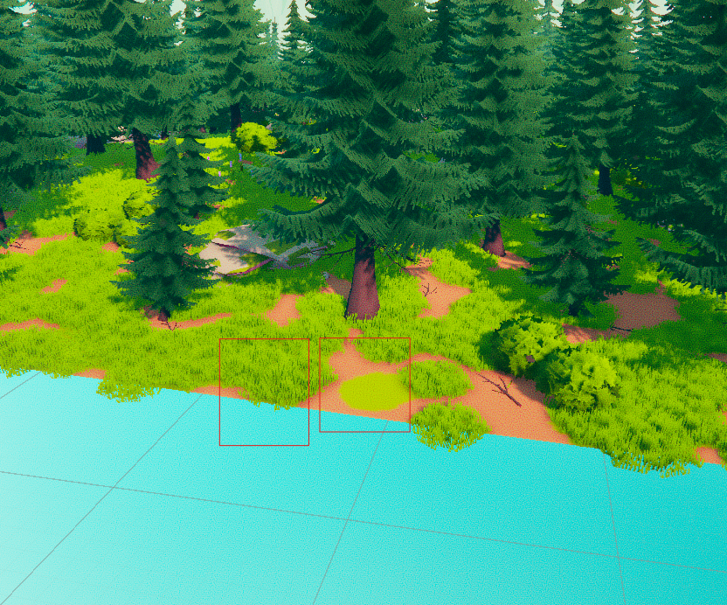

**Figure 10** *Grass prop at the left-hand side is currently rendered with LOD0 whereas the grass prop at the right-hand side is culled, not rendered at all.*

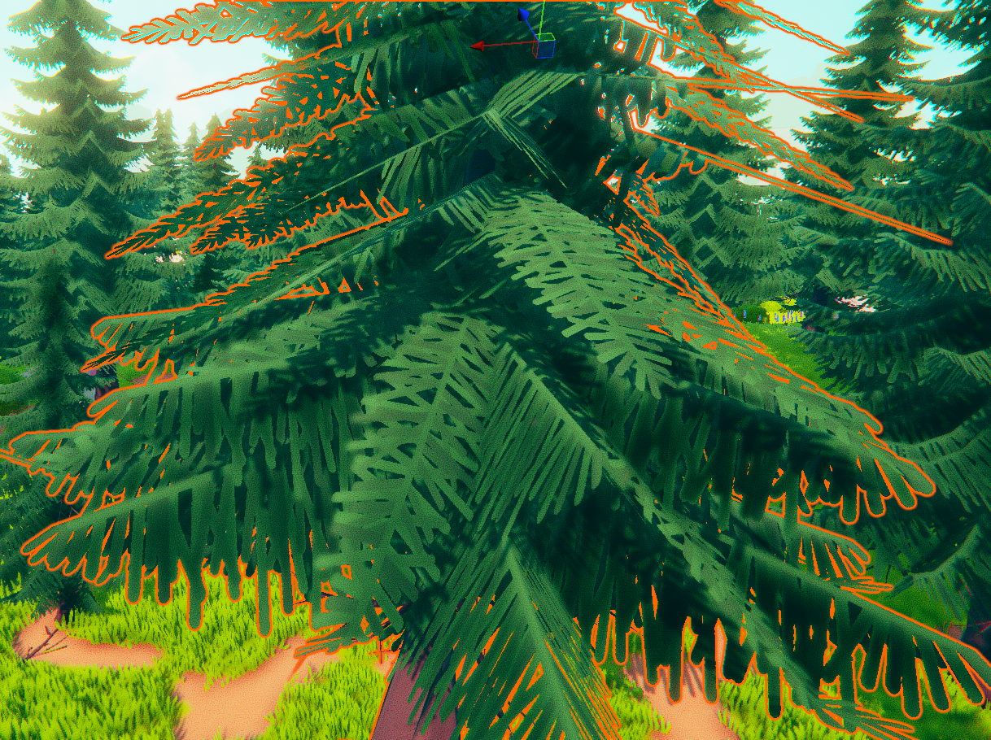

**Figure 11** *LOD level 3 Spruce tree prop close-up. The branches are almost 2d with only showing the most significant features of a tree.*

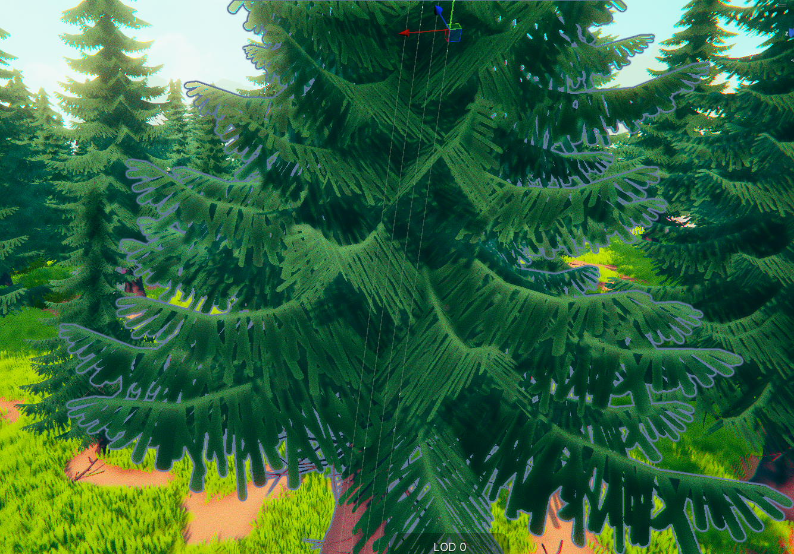

**Figure 12** *LOD level 0 Spruce tree prop close-up. Compared to figure 11, details are more obvious, curves of the branches are visible, the feeling of low-poly reduced.*

**Testing Character and Camera**

Testing character template is retrieved from a basic asset store character script interface and the parameters & scripts adjusted for LOD testing.

A LOD Tester class implementing MonoBehaviour is created to control LOD group levels, and L key is assigned as LOD group switch to showcase LOD effect on the performance during gameplay testing.

When player hits “L” all LOG groups toggle, different LOD levels and culling techniques starts working.



**Figure 13** *Test character*

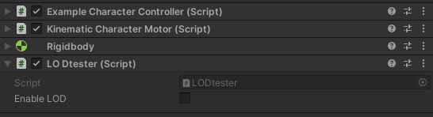

**Figure 14** *Added LOD tester script for in game LOD testing.*

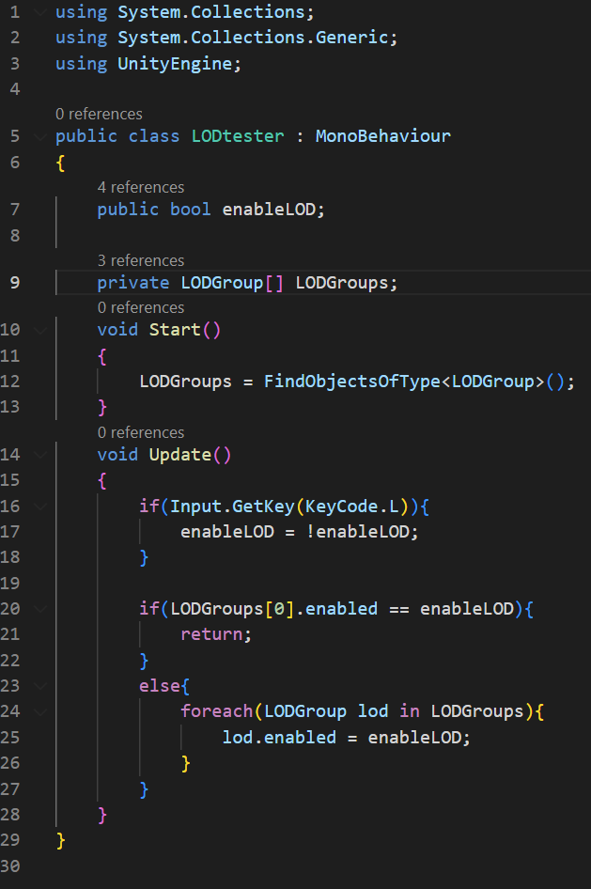

**Figure 15** *Added LOD tester script for in game LOD testing.*

Added L key to player control, it opens and closes dynamic LODs. When closed all lods stay at level 0 regardless of distance.

**Testing and Performance Review**

The performance test gameplay video has multiple stages.

Average culling, LOD levels disabled

1. Average culling LOD levels disabled
2. Aggressive culling LOD levels disabled
3. Minimal culling, LOD levels disabled
4. Average culling LOD levels **enabled**
5. Aggressive culling LOD levels **enabled**
6. Minimal culling, LOD levels **enabled**

**Result Table (GPU temp ~85 C degrees)**

|  |  |  |  |  |  |  |  |  |  |  |  |  |  |
| --- | --- | --- | --- | --- | --- | --- | --- | --- | --- | --- | --- | --- | --- |
|  | Average culling | | | | | Aggressive culling | | | | | Minimal culling | | |
| LOD disabled | **~16FPS** | | **~37-45%** | | **~95-98%** | **~50FPS** | | **~28-32%** | | **~85-88%** | **~4FPS** | **~29-35%** | **~40-50%** |
| LOD enabled | **~25FPS** | **~34-40%** | | **~95-98%** | | **~85FPS** | **~29-30%** | | **~65-75%** | | **~15FPS** | **~35-38%** | **~37-45%** |

*Values show: average FPS, CPU util. with the highest and the lowest values, GPU util. with the highest and the lowest values*

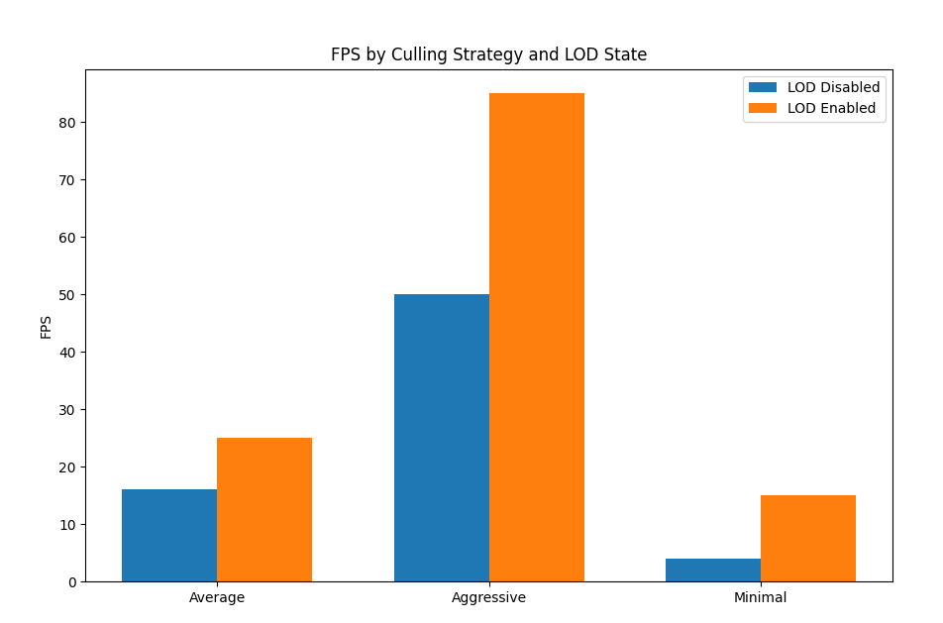

**Figure 16** *Test results visualized*

**(Bonus test) Result Table (GPU temp ~89 C degrees)**

|  |  |  |  |
| --- | --- | --- | --- |
|  | Average culling | Aggressive culling | Minimal culling |
| LOD disabled | **~14FPS** | **~47FPS** | **~3FPS** |
| LOD enabled | **~24FPS** | **~80FPS** | **~13FPS** |

*Values show: average FPS*

Lower FPS across all scenarios. Aggressive culling combined with LOD still offers the best performance (~80 FPS). Minimal culling is particularly problematic (~3 FPS with no LOD).

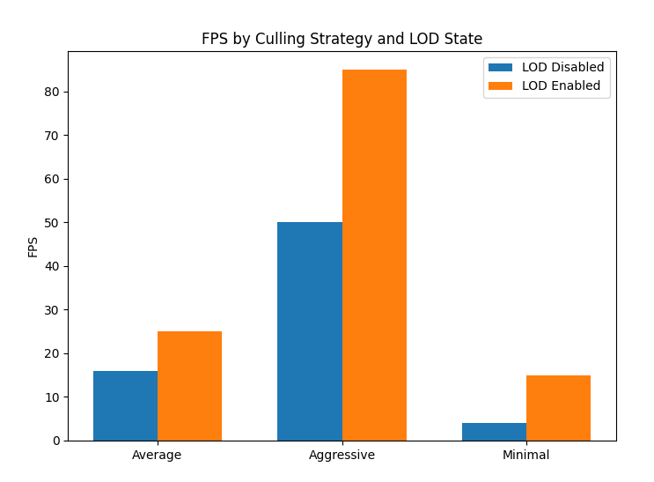

**Figure 17** *Bonus test results visualized*

**LOD Interval Testing**



**Figure 18** *LOD transition intervals. In order, test case and default case.*

|  |  |  |  |  |  |  |  |  |  |  |  |  |  |  |  |
| --- | --- | --- | --- | --- | --- | --- | --- | --- | --- | --- | --- | --- | --- | --- | --- |
|  | Average culling | | | | | | Aggressive culling | | | | | | Minimal culling | | |
| Test Case | **~28FPS** | | **33-40%** | | **~93-95%** | **~88FPS** | | | **~27-29%** | | **~63-74%** | **~17FPS** | | **~34-38%** | **~37-43%** |
| Default Case | **~25FPS** | **~34-40%** | | **~95-98%** | | **~85FPS** | | **~29-30%** | | **~65-75%** | | **~15FPS** | | **~35-38%** | **~37-45%** |

*Values show: average FPS, CPU util. with the highest and the lowest values, GPU util. with the highest and the lowest values*

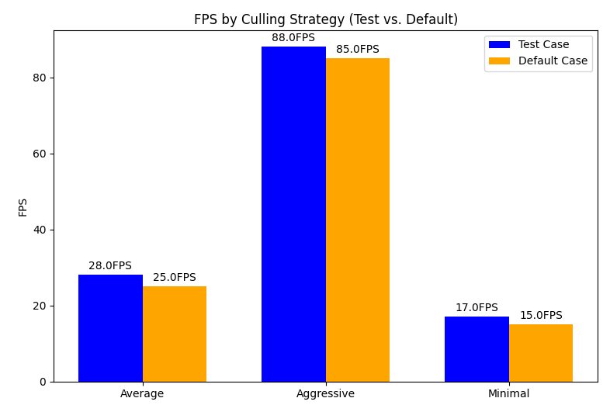

**Figure 17** *Interval test results visualized*

**Test Insights**

The performance tests conducted in Unity highlight the critical role of culling and Level of Detail (LOD) in optimizing gameplay performance and resource utilization. Six scenarios were tested, combining average, aggressive, and minimal culling with LOD levels either enabled or disabled, under a GPU temperature of ~85°C. When LOD levels were disabled, performance was highly dependent on the culling strategy. Average culling provided moderate results (~16 FPS) with CPU utilization peaking at ~95-98%, indicating a CPU bottleneck. Aggressive culling significantly improved performance (~50 FPS) by reducing the number of objects rendered outside the camera's view, which in turn decreased GPU utilization to ~28-32%. Minimal culling, however, performed poorly (~4 FPS), as almost all objects were rendered regardless of their visibility, resulting in inefficient resource use.

When LOD levels were enabled, there was a noticeable performance improvement across all scenarios. Average culling with LOD enabled increased FPS from ~16 to ~25, while CPU utilization remained constant (~95-98%), and GPU utilization slightly decreased (~34-40%). The combination of aggressive culling and LOD provided the best results, with FPS increasing from ~50 to ~85, CPU utilization dropping to ~65-75%, and GPU utilization further reduced (~29-30%). This combination efficiently minimized the rendering workload by both culling off-screen objects and lowering the detail of distant objects. Minimal culling, even with LOD enabled, still underperformed (~15 FPS), confirming that neglecting proper culling strategies leads to inefficient rendering and suboptimal gameplay performance.

An additional test conducted at a higher GPU temperature (~89°C) reinforced these findings. Performance degraded across all scenarios, with the aggressive culling and LOD combination maintaining the highest FPS (~80), while minimal culling and no LOD produced unplayable results (~3 FPS). These results demonstrate the importance of both culling and LOD in managing rendering complexity. The aggressive culling and LOD combination emerges as the optimal strategy for balancing FPS, CPU, and GPU workloads, ensuring smooth and efficient gameplay even under hardware limitations. These insights will guide further optimization efforts in the project to enhance real-time rendering efficiency.

**References**

[1]

<https://docs.unity3d.com/Manual/LevelOfDetail.html>

<https://indiegamesdevel.com/how-lod-systems-work-in-video-games-and-why-they-are-used/>  
<https://medium.com/@be.content23/exploring-unity-level-of-detail-lod-enhancing-performance-and-realism-in-your-games-01ad7ce78ab7>

<https://medium.com/@djolexv/maximizing-performance-with-level-of-detail-lod-optimization-techniques-999f9c973970>

[2]

<https://toxigon.com/understanding-level-of-detail-systems>

<https://discussions.unity.com/t/best-way-to-get-density-of-game-objects/487055>

<https://discussions.unity.com/t/performance-high-object-density-and-dynamic-lights/425573>

<https://discussions.unity.com/t/best-practises-for-texture-resolutions-and-optimisation/784581>

<https://unity.com/resources/performance-culling-techniques-webinar>

[3]

<https://docs.unity3d.com/6000.1/Documentation/Manual/FrameDebugger-landing.html>

<https://github.com/Whinarn/UnityMeshSimplifier>

<https://docs.unity3d.com/Packages/com.unity.pixyz.plugin4unity@2.0/manual/create-impostors.html>